University of Central Punjab

**Faculty of Information Technology**

# Object Oriented Programming

|  |  |  |
| --- | --- | --- |
| **Lab 16** | |  |
| **Topic** | Factory Design Pattern |
| **Objective** | The basic purpose of this lab is to revise some preliminary concepts of C++ that has been covered in the course of Introduction to Computing and Programming Fundamentals. Its objective is to recall previously learned basic concepts like revision of arrays, functions and pointers. |
|  | | |

**Instructions:**

* Indent your code.
* Comment your code.
* Use meaningful variable names.
* Plan your code carefully on a piece of paper before you implement it.
* Name of the program should be same as the task name. i.e. the first program should be Task_1.cpp

**Students are required to work in multiple files i.e .h and .cpp**

**Factory Design Pattern:**

Factory pattern is one of the most used design patterns. This type of design pattern comes under creational pattern as this pattern provides one of the best ways to create an object.

In Factory pattern, we create object without exposing the creation logic to the client and refer to newly created object using a common interface.

**Task 1:**

Implement the following class hierarchy using Factory Pattern.

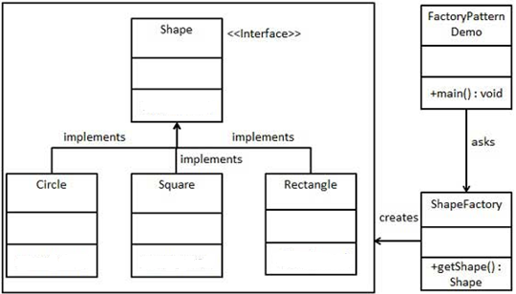

Write a function Area() to calculate area of each object of any shape.

* For Square: A = length*length
* For Rectangle: A = length*width
* For Circle: 𝐴 = 𝜋𝑟 2

**Task 2**

Implement the following hierarchy of shop management system as shown below in (incomplete) UML diagram. Add attribute and functions by considering the requirements.

The ShopManagement is a parent class, which saves and updates the entire record (person’s and his mobile’s information). Two classes Mobile and Person are associated with it. The Mobile class is publically inherited by Nokia, OPPO and QMobile. Whereas the person is categorized as salaried employee or Businessman. The given hierarchy depicts the above statement in graphical way.

**Important**: We are interested in polymorphism relationship (see main for details). Consider the given main() and expected output, and write complete clear and clean code. Do not use string library for any purpose.

